Enlighten web addresses

For administration <http://documents/enet1/Admin/>

For document search and viewing <http://documents/enet1/netdfm>

Support Website

<http://support.enlighten.net/default.aspx>

login - email address

pw - MultipleMonitors

Will not be able to use the NAS? Drive must be locally attached to the server hosting Enlighten.

Permissions on enet1 – Should domain-giga\administrators be in this list?

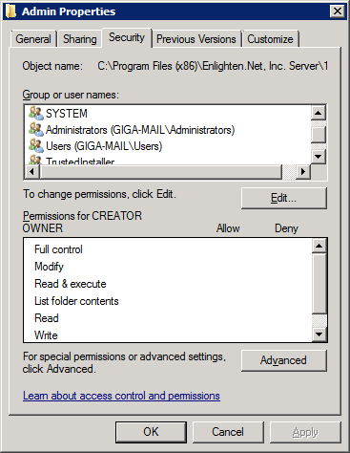

Setup email – SMTP information – on GIGA-Mail

Need to setup backup for critical Enlighten components – What are the files needed for backup for a disaster recovery plan c:\enetdata1 entire folder? YES

What folder do we move documents from the S: drive (NAS) to on GIGA-Mail to make them accessible by Enlighten?

Example Capture Directory: \\GIGA-MAIL\Net.Scan1\Packing_Lists

The Enlighten software will then move the document from the capture directory and place it in one of the numbered directories (enlighten converts folder names to numbered directories) Example Packing List capture directory actually moves the document to the following location C:\enetdata1\netdfm\9 on the giga-mail server. The document that is copied here does not keep its name – it is renamed by Enlighten.

How to create folders and capture directories.

You need to create a folder under <http://documents/enet1/Admin/TabGeneralAdmin.aspx>

And the Maintain Folders link – click the green plus to create a new folder

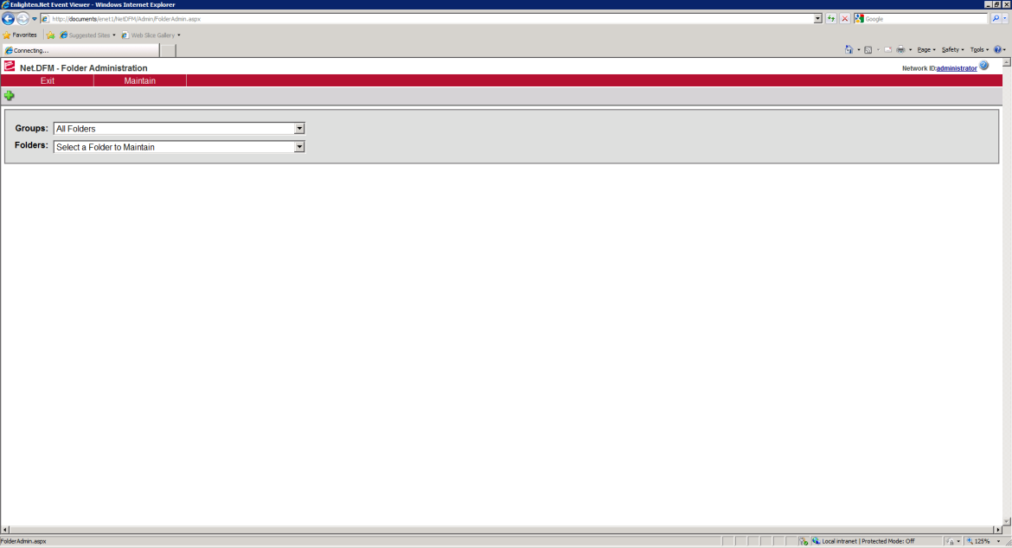

You then need to create a Capture Directory under the Capture Directories link

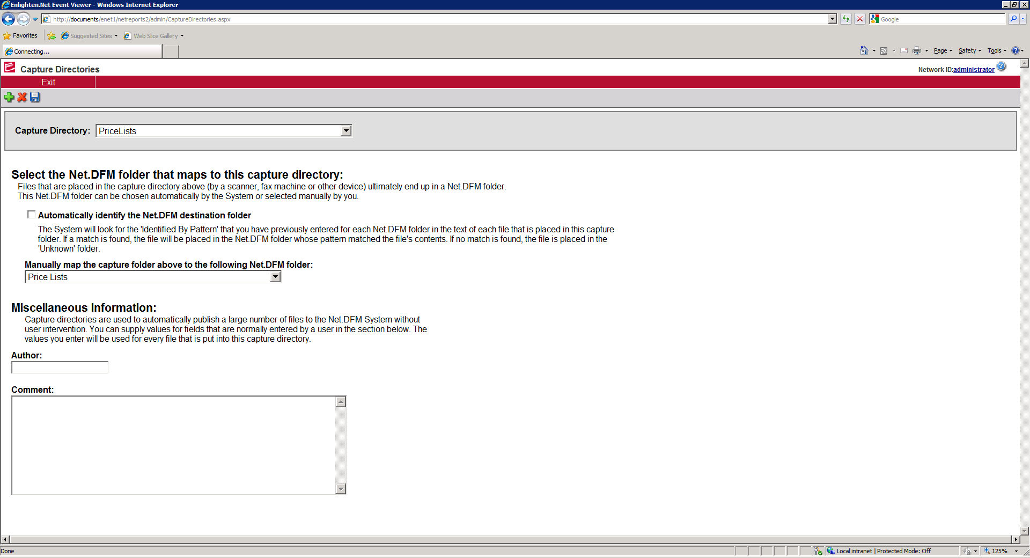

How do you change or modify a DNS alias?

If you change or add a DNS alias you will also need to change in outbound email (registry entry?)

May need to uninstall Exchange Server 2007 from giga-mail

How do users get to the Net.DFM – Digital File Manager page?

<http://documents/enet1/netdfm/>

Do I need to setup permissions in IIS?

When trying to access this link with a user account (other than one with domain admin rights) a login for giga-mail pops up). What needs to be done to grant permission to users? The test account “gigasales” has been imported into Enlighten.Net Admnistration – User List but still cannot access the <http://documents/enet1/netdfm/> site.

*(This was a registry entry change that was made on the giga-mail server. HKEY_LOCAL_MACHINE – SOFTWARE – Enlighten.Net, Inc. Server – Right click on this folder and select permissions – gave domain-users read permissions – the gigasales account was then able to access netdfm site.)

How do you get to the Best Practice Englighten.Net document? Best Practice document G52606

How do you login to the support website? Is this where I have an account setup with password of – “MultipleMonitors”. Login is email address. Where can additional documentation be found?

<http://support.enlighten.net/default.aspx>

Is Authorization Manager automatically installed on Windows Server 2008 R2? Does it have to be configured? Page 13 of NetDFM – Administration

Authorization Manager is installed by default on Windows Server 2008 – You first have to launch the MMC - start – run mmc this will pull up the Microsoft Management Console. You then need to add the snap-in for the Authorization Manager. You must then browse to C:\Program Files (x86)\Enlighten.Net, Inc. Server\1\Conf and rename the “master_authstore” xml file to just authstore. You will then right click on the Authorization Manager in the MMC and select Open Authorization Store and browse to the authstore xml file you just renamed. This will give you the ability to control if users have the ability to email from Enlighten, you can also lock down the purge file option and various other security controls inside of the Enlighten application.

How do you add Comments or User Fields Sections?

When adding information to the Comments or User Fields sections, this must be done after scanning the document. You must pull up the document in the Enlighten software and add the information, you cannot add the information while scanning the document.

When adding searchable criteria to a scanned document (Ex. Airgas Document 13) How do you make it easier to search for this content? I added it to the comments section and to user fields, but when I search I have to actually select property search to get a hit on one of these fields. Is there a way to make it search both the document (Content Search) and Property Search at the same time?

There is a check box labeled In Addition to document contents, also search all document properties.

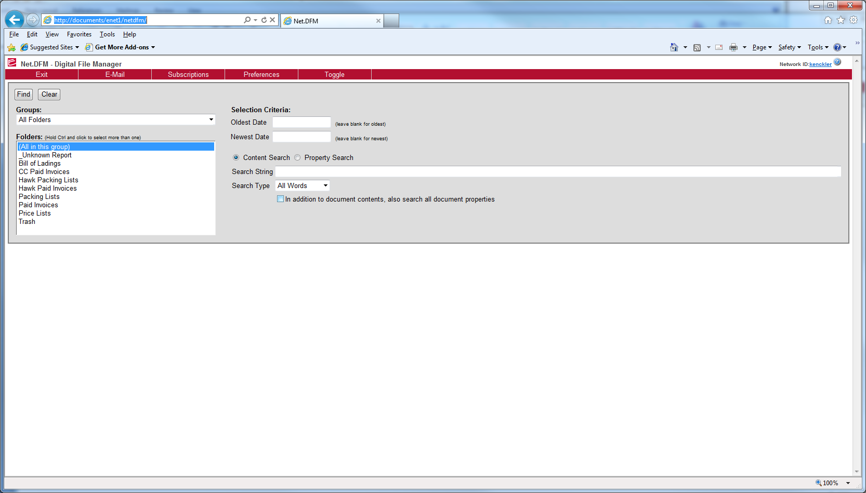

I added “airgas” to a User Field Name for Document 13 and when I search for airgas in User Field Name it pulls up Document 9, why?

What are some of the limitations of the Enlighten search engine?

You cannot scan words that are typed and have hand written or circles around them, this messes up the OCR software. Also handwritten information will not be searchable, OCR software cannot interpret various forms of handwriting.

Network folder browsing? I have noticed I have to login as administrator to setup a network folder. Can this be setup by the user who logs in? Can I specify a default location for each user that logs in? For instance if Matt logs in can it default to a folder named Matt? Or will I have to specify a folder for each user? Better option would be a folder for Sales. Then the sales rep that scans the document is responsible for moving it to another location and possibly renaming.

What causes documents to become locked? Are administrators the only ones who can unlock resources? Is there a way to auto unlock a document or setup a job to unlock documents at night?

Documents can become locked by clicking closing the browser window with the “X” in the corner of the browser. Once locked, only an administrator or the person who has the file opened can unlock this file. When a file is locked you can still view the document you just cannot edit the document.

What will be the best way to scan Packing Lists for example? As each individual file or as a stack of different packing lists that will save one multi page document? If you scan say all of the Packing Lists that start with the letter P to one file you can use the Enlighten search engine to find your “Power Sonic” document even though it is only one page of all of the Packing Lists that were scanned with the letter P.

Probably the best way will be to scan a group of packing list for a date range. This will give you the ability to let the Enlighten software do the work for you while not creating too many single page documents that make the scanning process overly time consuming. This will also give you the ability to scan on a data range (this date range is when the file was scanned, not the actual date of the packing list).

How do you make the folders setup in Enlighten viewable by the scanner?

You have to setup the scanner to view the capture directories you create in the Enlighten Administration module.

When clicking exit from this page you receive the following message on the server.

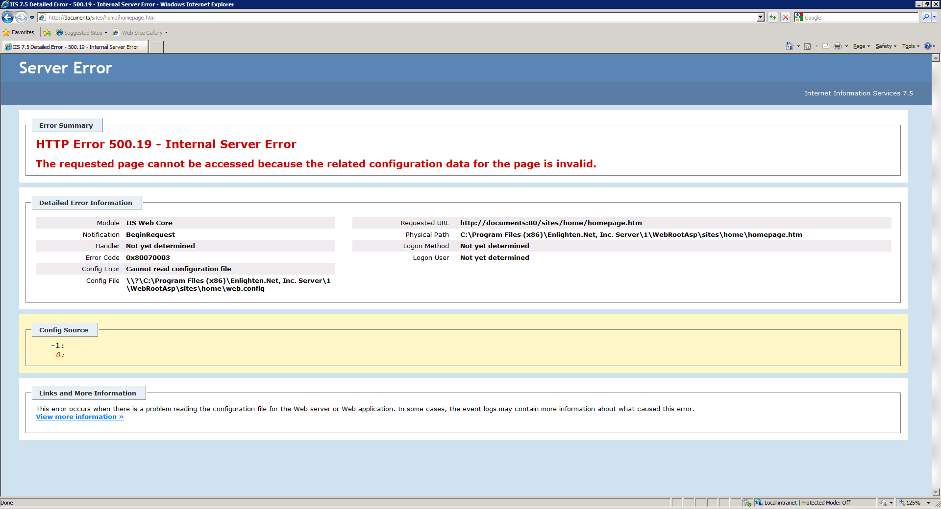

When clicking exit from a pc that was logged into the Net.DFM – Digital File Manager page the following page is displayed.

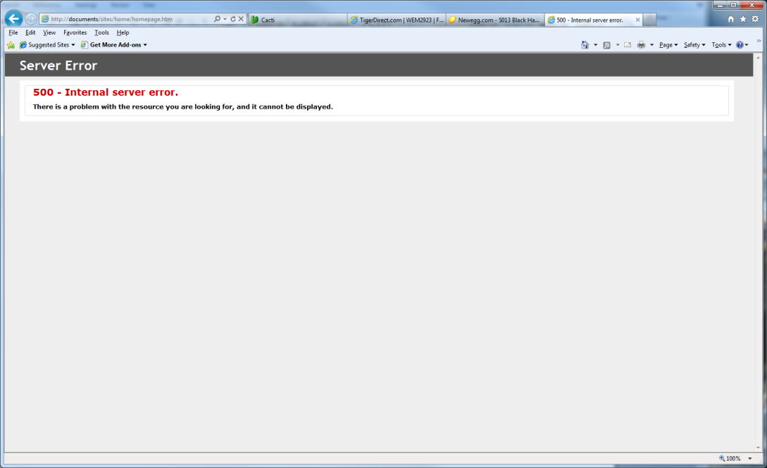

What options have we purchased?

We would like to use the in / out board is this an intranet only option?

What do we need to do to install the intranet portion of enlighten?

What about the Net.Reports?

How long should it take after scanning documents to be able to search for them? I have noticed sometimes I can search and find a document immediatley other times it seems I have to wait for more than 15 minutes before it can be searched. (This is taking into account the document has left the scanner and the OCR at the scanner level has finished.) Is there indexing happening on the Enlighten side?

When first creating a folder and capture directory, the Enlighten software has to wait for Windows Index services to index the folder. This is why there is sometimes a long delay. But once the folder has been indexed, you should be able to search for a scanned document minutes after scanning the document.

If for some reason a new folder is added and you cannot search the folder then the indexing service may be hung on the server. You can open the Indexing Service in the MMC and check to see if the recently created folder is listed under the directories folder, if not then right click on the Indexing Service on Local Machine and stop and start the service. This has fixed the issue in the past.

We need clarification on the search options.

When selecting all words as the search option and searching for “on the mark” we receive hits for “the”.

When searching for “On The Mark” and selecting as a search option Exact Phrase. We receive hits on “the” throughout , why is it not searching the exact phrase “on the mark”?

This occurs do to the fact that when the document is pulled up adobe the uses its find option and inserts an or command for each word (on ‘or’ the ‘or’ mark). If you click the “New Search” button and then click the “Search” button, it will find the exact phrase you were searching for.

Should I setup capture directories for every folder created in Enlighten?

You do not have to. You do have the option of setting up the Identified By Pattern. This function allows you to setup a word such as “Packing List” that the scanner would look for on a specified page (preferably 1) and the software would use this to place the document in the correct enlighten folder.

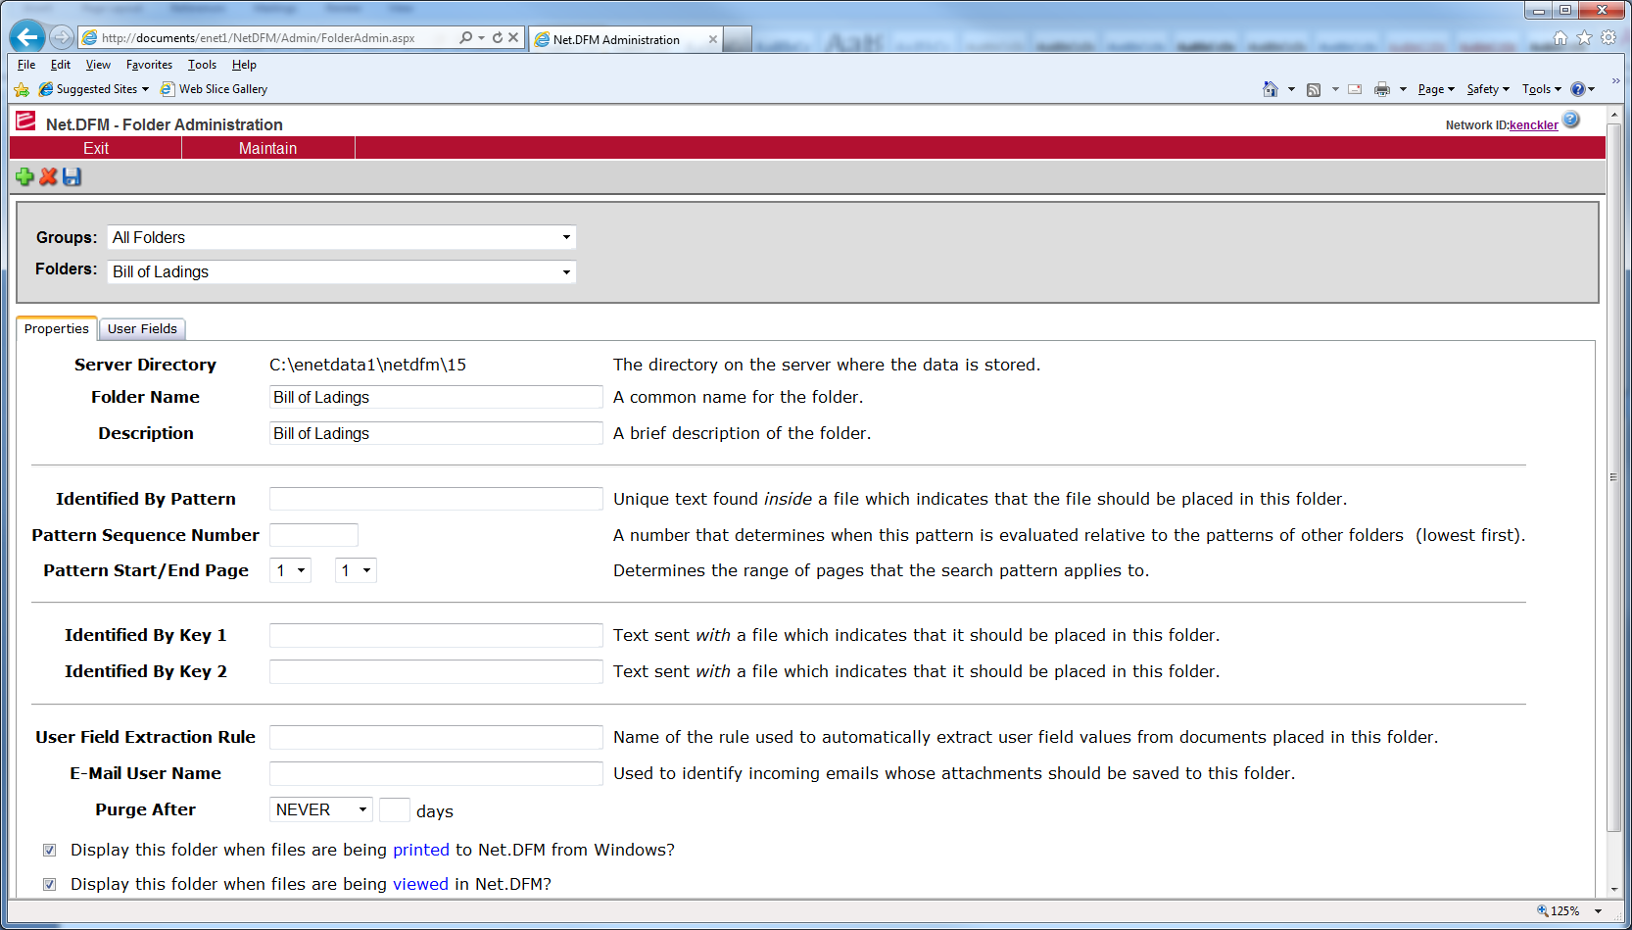

We would then setup the capture directory “AutoIdentify”. This capture directory is already created, we just need to make it visible to the scanner. You would then select this directory as the scan directory and the Identified Pattern would be used to place the document in the correct folder.

When refreshing with an Enlighten web page, changes don’t show, you have to actually launch the web page again from your favorites. Is this the way to refresh the page?

There is a user file located in the following location

C:\Program Files (x86)\Enlighten.Net, Inc. Server\1\Webroot

The following line must be changed in the user file

<add key="MainHomePageUrl" value="/enet1/netdfm"/>

This specifies the main page or the page that is used when clicking refresh. To make the changes take effect after editing this file, you must open the Web file in the same directory and add a space and save the file, this will cause the file to be reread by the Enlighten application.

Scanning duplex vs simplex. Can you change the order of the documents scanned after scanning? What if you open the actual pdf in the C:\enetdata1\netdfm\XX directory using adobe professional can you manipulate the page structure? Will this impact other functionality in Enlighten for this document?

How do we email or send one page of a file? We are scanning 50 – 100 packing lists per file and may need to send just one page out of this document. How do we send (we can print the one page but when we select print to a file it does not save in a pdf format.

This is a limitation of the software. Jerome thinks there is an option when scanning to save every page as a separate pdf file. Then we would have to choose the lesser of two evils, a three page document would now be three separate pdf files, or have 100 packing lists contained in a single file. Another option is printing the single page that is needed and rescanning to send. Another option would be to obtain the .report functionality of enlighten and then we could print a single page to enlighten without having to rescan the document.

I am receiving an error when trying to setup security on folders.

This is a known issue; you should use NTFS permissions on the numbered folders on the server. EnetAdminUser is a member of the Administrator’s group on the server, so the Administrator account must have full access to the folders, other than this you can use NTFS permissions to lock down these folders to user level access.

Screen shot of error message when clicking on the deny button for folder security.

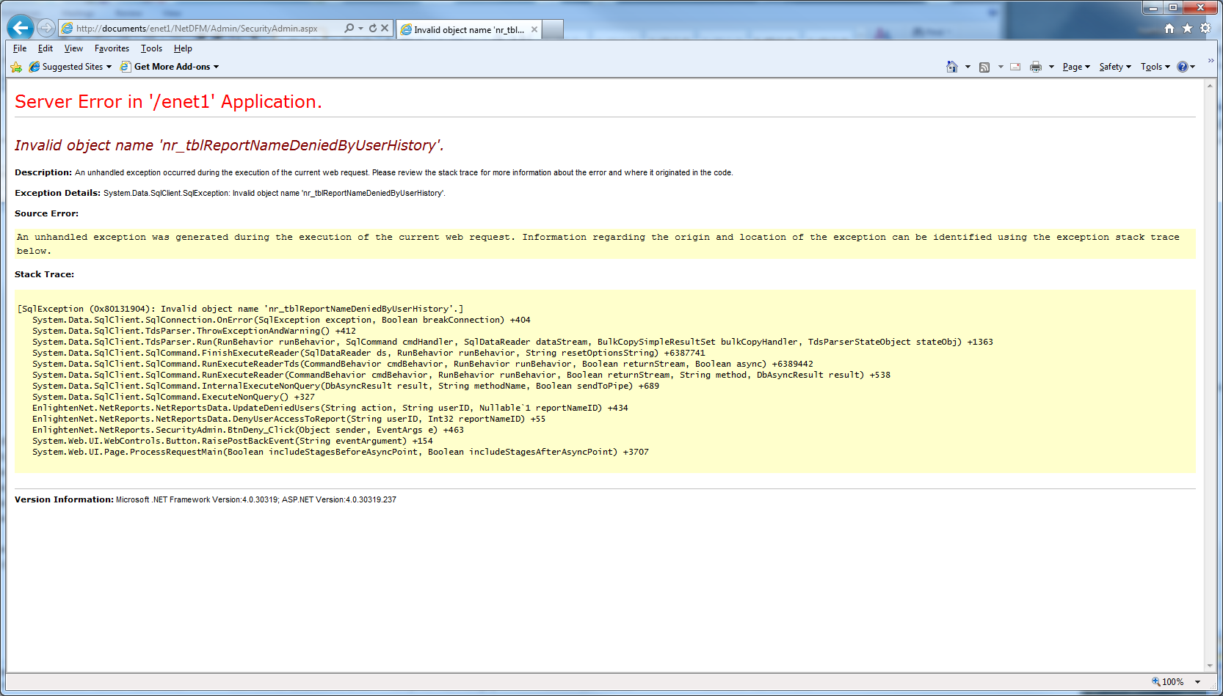

How do you correlate the numbered directories to the named folder in Enlighten? Do permissions need to be set on these folders?

Need to get a better understanding of permissions: Both folder NTFS security and application level permissions.

This goes back to using NTFS on the folders for user level access. This is the preferred way to maintain security on the folders in Enlighten.

Subscribe folders – What is the difference between Current User and Copy to User?

When logged into the Administration console in Enlighten you have the option to select the current user and copy all of their subscriptions to the selected user. This is to make copying role access for subscriptions easier.

The time is off on scanned documents, but the time on the server is correct.

Once the user has opened the <http://documents/enet1/netdfm/> link, there name will show up in the top right corner. If they click on this and there will be a quick message that pops up about time zone offset saved. They can the click the save button in the top left corner and this will save the time zone offset of 300, this is 300 minutes above GMT time. Jerome is working on an update to fix this automatically, once a user has saved this setting though it does not change.

How to add users – what to enter to query DOMAIN-GIGA – I have added users before but can’t seem to query the right thing, have tried DOMAIN-GIGA, DC=DOMAIN-GIGA

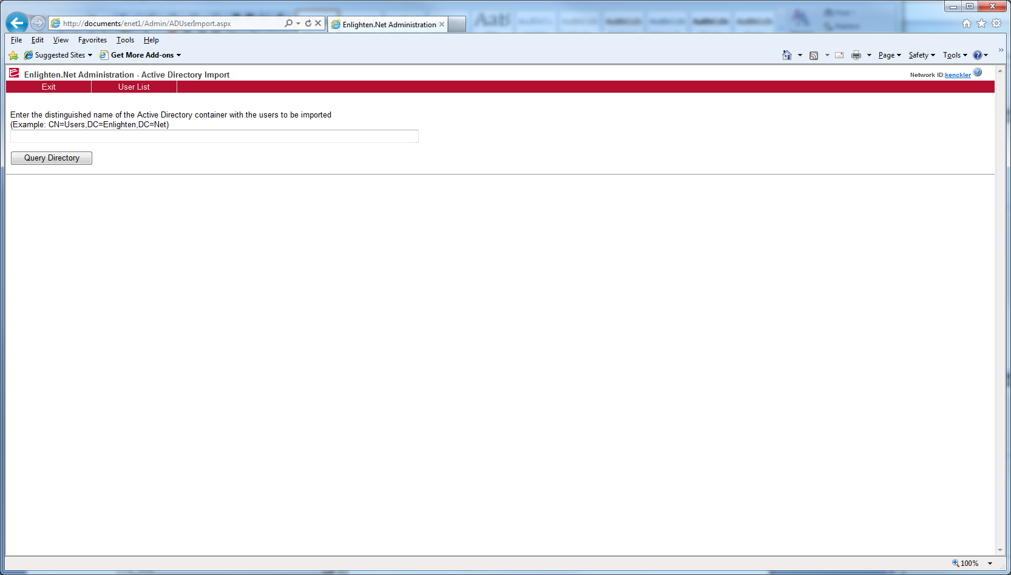

How do you query users from the Administration module in Enlighten?

To Query Users from the Enlighten Administration module, you must be on the enlighten server, GIGA-Mail. Then you can use the following line to query users from active directory.

CN=USERS,DC=DOMAIN-GIGA

Can we doclink enlighten scanned documents to P21?